1.Overview

1.1. Introduction
- The Timer IP is an essential peripheral in SoC designs, used to count system clock (sys_clk) cycles for accurate time measurement. It communicates with the CPU via the APB bus, supporting register configuration, interrupt management with RW1C clearing logic (TIER, TISR), and a debug halt mechanism (THCSR + dbg_mode).
- Applications:
- Periodic Interrupt Generation: Asserts the interrupt signal (tim_int) periodically for RTOS ticks or task scheduling.
- Hardware Delays: Provides precise timing delays without consuming CPU processing cycles.
- Time Measurement: Tracks event durations and measures pulse widths or frequencies.
- Debug Support: Freezes the internal counter in Debug Mode (dbg_mode == 1) to preserve system state during debugging.

1.2. Main features
The Timer IP design supports the following key hardware features:
- Standard APB Slave Interface: Seamlessly integrates with the SoC via the AMBA APB protocol (32-bit data bus, 12-bit address bus).
- Byte Strobe Support: Enables precise byte-level write access using the tim_pstrb[3:0] signal.
- Flexible Interrupt Management:
- Configurable interrupt enable/disable control via the TIER register (int_en).
- Interrupt status flag in TISR (int_st) featuring RW1C (Write-1-to-Clear) access mechanism to prevent accidental status clears.
- Highest priority given to software interrupt clearance over hardware interrupt generation when occurring simultaneously.
- Flexible Counter Core: Continuously increments the internal counter and compares it against a preset compare_val to generate the tim_int output.
- Debug Halt Mechanism:
- Allows freezing the counter via the halt_req bit in the THCSR register.
- Safely pauses the counter only when the SoC is in Debug Mode (dbg_mode == 1), asserting the halt_ack = 1 status flag to facilitate system debugging.

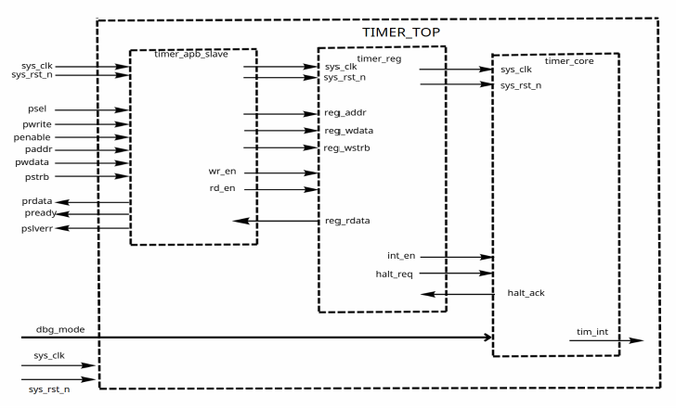
Counter Core
- Purpose: Executes the actual time-counting function, handles the debug halt logic, and generates the output interrupt signal.
- Functions:
- Halt Control Logic: Determines the internal count enable condition based on the debug status (dbg_mode) and halt request (halt_req).
- Counter: Increments the timer counter value on every active system clock (sys_clk) cycle.
- Comparator: Compares the current counter value against the target threshold (compare_val). When a match occurs, it generates the hw_set_int signal to assert the TISR.int_st flag in the Register File.
- Interrupt Signal Generation (tim_int): Combines the interrupt flag (TISR.int_st) and interrupt enable bit (TIER.int_en) using an AND logic gate to drive the output interrupt signal (tim_int) to the CPU.

Interface signals
Table 1: Interface signals of timer IP
Signal name | Width | Direction | Description
sys_clk | 1 | Input | Global system clock signal.
sys_rst_n | 1 | Input | Global system reset signal (Active Low).
tim_psel | 1 | Input | APB peripheral select signal.
tim_enable | 1 | Input | APB transfer enable signal.
tim_pwrite | 1 | Input | APB transfer direction (1: Write, 0: Read).
tim_paddr | 12 | Input | APB address bus (12-bit).
tim_pwdata | 32 | Input | APB writes data bus (32-bit).
tim_pstrb | 4 | Input | APB writes strobe signals for byte-level control.
tim_rdata | 32 | Output | APB read data bus (32-bit).
tim_pready | 1 | Output | APB ready signal indicating transfer completion.
tim_pslverr | 1 | Output | APB slave error signal (tied to 1'b1).
dbg_mode | 1 | Input | Debug mode status signal from system.
tim_int | 1 | Output | Timer interrupts output signal to CPU.

